

Procedure
for
PostgreSQL Source Code installation

Document Control
Document No. | PSQL-4-024
Document Name | PostgreSQL source code installation
Last Review | 22-04-2024
Next Review Date | 22-04-2025

Version History
Version No. | Last Review | Changes
1.0 | 22-04-2024 | Original document

Authorization Matrix
(Name & Designation)
Version No. | Creator  (Functional team) | Reviewed By  (Functional team) | Approved By  (Functional team) | GRC - Head
1.0 | Akshay Kank | Swarnima Sinha | Avdhesh Choursiya | Shailesh Purani

Reference Documents
Document No. | Document Name
NA | NA

INDEX
1 Overview 4
2 Objective 4
3 Scope 4
4 Activities 4
5 Forms & Checklists 8
6 Safety Precautions 8
7 Contact 9
8 Definition 9

Overview
PostgreSQL tool is highly versatile and offers a wide range of functionalities for database management and interaction. With relational database management system. features transactions with Atomicity, Consistency, Isolation, Durability (ACID) properties. It is a free open source database system.

Objective
The objective of this document is to understand the process steps for PostgreSQL installation through source code.

Scope
  - This document applies to NTT Global Data Centers and Cloud Infrastructure India Private Limited, Netmagic Solutions Private Limited, NTT India Solutions Private Limited and NTT Communications India Network Services Private Limited hereafter jointly referred to as “NTT Companies in India”.
  - This process is applied to all individual who are involved in .
  - Individuals means employee (permanent, temporary, contract, trainee, etc.), staff of vendor, contractor, third party or any person.

Activities
Postgresql Source Code Installtion Steps:
1}. Download tar file using chrome and install in vm
wget https://ftp.postgresql.org/pub/source/v14.9/postgresql-14.9.tar.gz
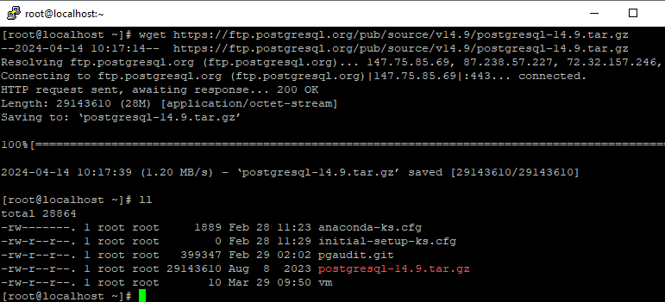

2} tar -xvzf postgresql-14.9.tar.gz
untar this tar file

3} Create bin & directory
sudo mkdir -p /usr/lib/pgsql-14.9
mkdir -p /home/data

4} create on user postgres
adduser postgres

5} change owner pgsql and data directory
chown postgres:postgres /home/data
chown postgres:postgres /usr/lib/pgsql-14.9

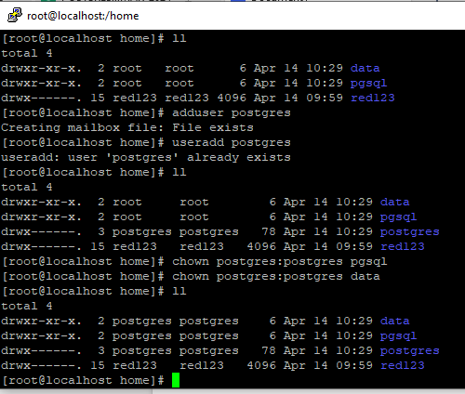

6} open untar file and wirte ./configure -- prefix=/home/pgsql/
Create your bin directory
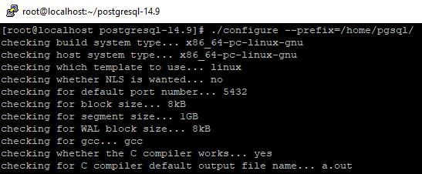

7} make
8} make install
9} Switch to postgres user su - postgres

10} install cluster
/home/pgsql/bin/initdb -D /home/data/ {in postgres user}

11} Then Write logstart command
/home/pgsql/bin/pg_ctl -D /home/data/ -l logfile start

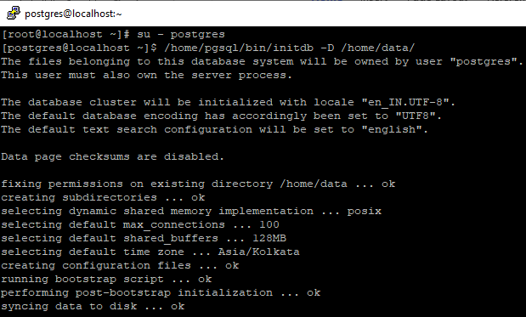

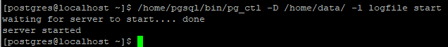

12} Database is up Now I want Connect Database to psql
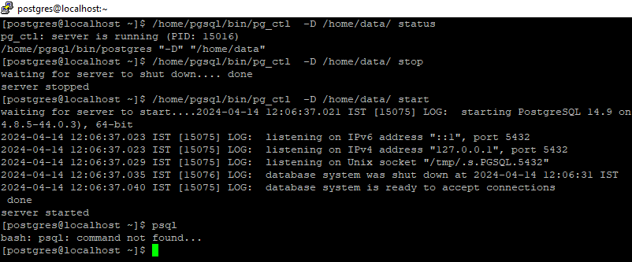

13} Add service and Set Environment in vi .bash_profile

14} vi /etc/systemd/system/postgresql.service {add service}

[Unit]
Description=PostgreSQL Database Server
After=network.target

[Service]
Type=forking
User=postgres
ExecStart=/home/pgsql/bin/pg_ctl -D /home/data start
ExecStop=/home/pgsql/bin/pg_ctl -D /home/data stop
ExecReload=/home/pgsql/bin/pg_ctl -D /home/data reload
#PIDFile=/run/postgresql/14-main.pid
TimeoutSec=-10

[Install]
WantedBy=multi-user.target
~

15} Set Environment cd /var/run
Create one folder postgresql
Chown owner that folder

16} write in postgresql folder vi .bash_profile
export PATH=/home/pgsql/bin:$PATH
export PGDATA=/home/data
export PGPORT=5432
export PGDATABASE=postgres
export PGHOST=/run/postgresql

17} change postgres.conf file
vi /home/data/postgres.conf

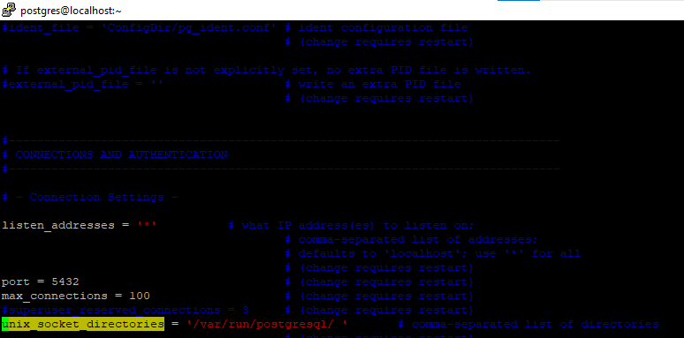

18} Then start the service And check psql commnad working or not
postgres:~$ psql

Forms & Checklists
NA

Safety Precautions
NA

Contact
For clarification, suggestion or further information on this process, Please contact Process Creator, Process Owner/ Approver (HoD) and/ or mail to@NTTIN DL-PostgreSQL <nttin.db.postgresql@global.ntt>; @NTTIN DL-DB MySQL <nttin.db.mysql@global.ntt>

Definition
Installing PostgreSQL from source code involves compiling the PostgreSQL source files into executable binaries and libraries, configuring the system settings, and installing the compiled binaries onto the target system. This method provides greater flexibility and control over the PostgreSQL installation process, allowing customization of features, optimizations, and integration with specific system configurations.

